Title of the Paper (Times New Roman, Font Size 24, Center, Title Case)

First Author¹, Second Author², and Third Author³ (Times New Roman, Font Size 11, Title Case)
Abstract: The abstract must be a concise yet comprehensive reflection of what is in your article. In particular, the abstract must be self-contained, without abbreviations, footnotes, or references. The abstract should not be more that 200 words. Be sure that you adhere to these limits; otherwise, you will need to edit your abstract accordingly. The abstract must be written as one paragraph, and should not contain displayed mathematical equations or tabular material. Ensure that your abstract reads well and is grammatically correct. (Times New Roman, Font Size 9, Bold, Justified)

^{*1}First Author Affiliation, Email ID (Times New Roman, Font Size 9, Center, Title Case)

²Second Author Affiliation, Email ID (Times New Roman, Font Size 9, Center, Title Case)

³Third Author Affiliation, Email ID (Times New Roman, Font Size 9, Center, Title Case)
Index Terms: Enter at least 5 key words or phrases in alphabetical order, separated by commas. (Times New Roman, Font Size 9, Bold)

Introduction
This document is a template for Microsoft Word versions 6.0 or later that can be downloaded from the Journal of Scientific Research (JSR) website to prepare your manuscript.
Define abbreviations and acronyms the first time they are used in the text, even after they have already been defined in the abstract. Do not use abbreviations in the title unless they are unavoidable (for example, “TCP/IP” in the title of the article).

Manuscript Organization
In general, manuscripts may contain Title, Authors’ names, Affiliation, E-mail address, Abstract, Keywords, Introduction, Literature Survey, Proposed Approach, Results and Discussion, Conclusion, Experimental Section, Acknowledgments, References and Endnotes. However, authors can organize the contents of the manuscript according to their requirements.

Guidelines For Manuscript Preparation
When you open JSR .docx template, select “Styles” from the “Home” tab (Home >> Styles), (these instructions assume MS Office 2007. Some versions may have alternate ways to access the same functionalities noted here). Then, type over sections of the template or cut and paste from another document and use markup styles. The pull-down styles menu is at the right of the Formatting Toolbar at the top of your Word window. Highlight a section that you want to designate with a certain style, and then select the appropriate name on the style menu. Authors can also copy desired formatting from the template by using Format Painter tool to format their contents. The style will adjust your fonts and line spacing. Do not change the font sizes or line spacing to squeeze more text into a limited number of pages. Use italics for emphasis; do not underline.
Main text of the manuscript inside each heading is Times New Roman, font size 10, justified alignment, and 1.15 line spacing. First line of each paragraph is indentation by 0.14” tab space.

First Level Heading
Author can format first level heading (for example “Introduction”) by selecting “Heading 1” Style from the formatting toolbar in MS Word. That is numbered with Roman Numerals, Times New Roman, font size 10, all capital letters, center aligned, and having paragraph space before and after the heading.

Second Level Heading
Author can format second level heading (heading within first level heading) by selecting “Heading 2” Style from the formatting toolbar in MS Word. That is numbered with capital letter Alphabet, Times New Roman, font size 10, italic, title case, left aligned with 0.14” tab space, and having paragraph space before and after the heading.

Third Level Heading

Author can format third level heading (heading within second level heading) by selecting “Heading 3” Style from the formatting toolbar in MS Word. That is numbered with Numeric value followed by a bracket ‘)’, Times New Roman, font size 10, italic, title case, and left aligned with 0.14” tab space. Text within third level heading has left indentation of 0.2”.

Fourth Level Heading
Table I. Variables used in algorithm and their description
Variable | Descriptionª
$$HMT_{Root}$$ | Pointer of root process node in HMT
$$P_{i}$$ | A parent process
$$P_{i}C_{j}$$ | A child process of $P_{i}$
$$P_{k}C_{l}$$ | A recovered process
$$S_{id}P_{i}C_{j}$$ | Sequence number of next message to be sent to $P_{i}C_{j}$
$$R_{id}P_{i}C_{j}$$ | Sequence number of next expected message from $P_{i}C_{j}$
$$M_{id}P_{i}C_{j}$$ | Sequence number of respond message from $P_{i}C_{j}$
$$F_{i}$$ | Faulty process list of $P_{i}$
$${FP}_{i}C_{j}$$ | Faulty process list of $P_{i}C_{j}$
$$f_{i}$$ | A process in the list ${FP}_{i}C_{j}$
$${To}_{i}\left[P_{i}C_{j}\right]$$ | Timeout of respond message from $P_{i}C_{j}$
$$CTree$$ | Pointer of a recovered process node in HMT
$$FTree$$ | Pointer of a faulty process node in HMT
N, D | 1 → 1/(4π)
ªDescription represents the use and importance of variables.

Author can format fourth level heading (heading within third level heading) by selecting “Heading 4” Style from the formatting toolbar in MS Word. That is numbered with small letter Alphabet followed by a bracket ‘)’, Times New Roman, font size 9, italic, title case, and left aligned with 0.3” tab space. Text within third level heading has left indentation of 0.5”.

Ordered and Unordered List
Ordered List is formatted as following.
- Numbered with numeric
- Left indentation of 0.13”
- Hanging by 0.19”
Unordered List is formatted as following.
- Solid filled circle bullets
- Left indentation of 0.13”
- Hanging by 0.19”

Math
If you are using Word, use either the Microsoft Equation Editor (Insert >> Equation) or the MathType add-on (http://www.mathtype.com) for equations in your paper (Insert >> Object >> Create new >> MathType Equation).

Equations
Number equations consecutively with equation numbers in parentheses flush with the right margin, as in Eq. (1). First use the equation editor to create the equation. Then select the “Equation” markup style. Press the tab key and write the equation number in parentheses. Use parentheses to avoid ambiguities in denominators. Punctuate equations when they are part of a sentence, as in
${\left(x+a\right)}^{n}=\sum_{k=0}^{n}{\left({n \atop k}\right)x^{k}a^{n-k}}$ (1)
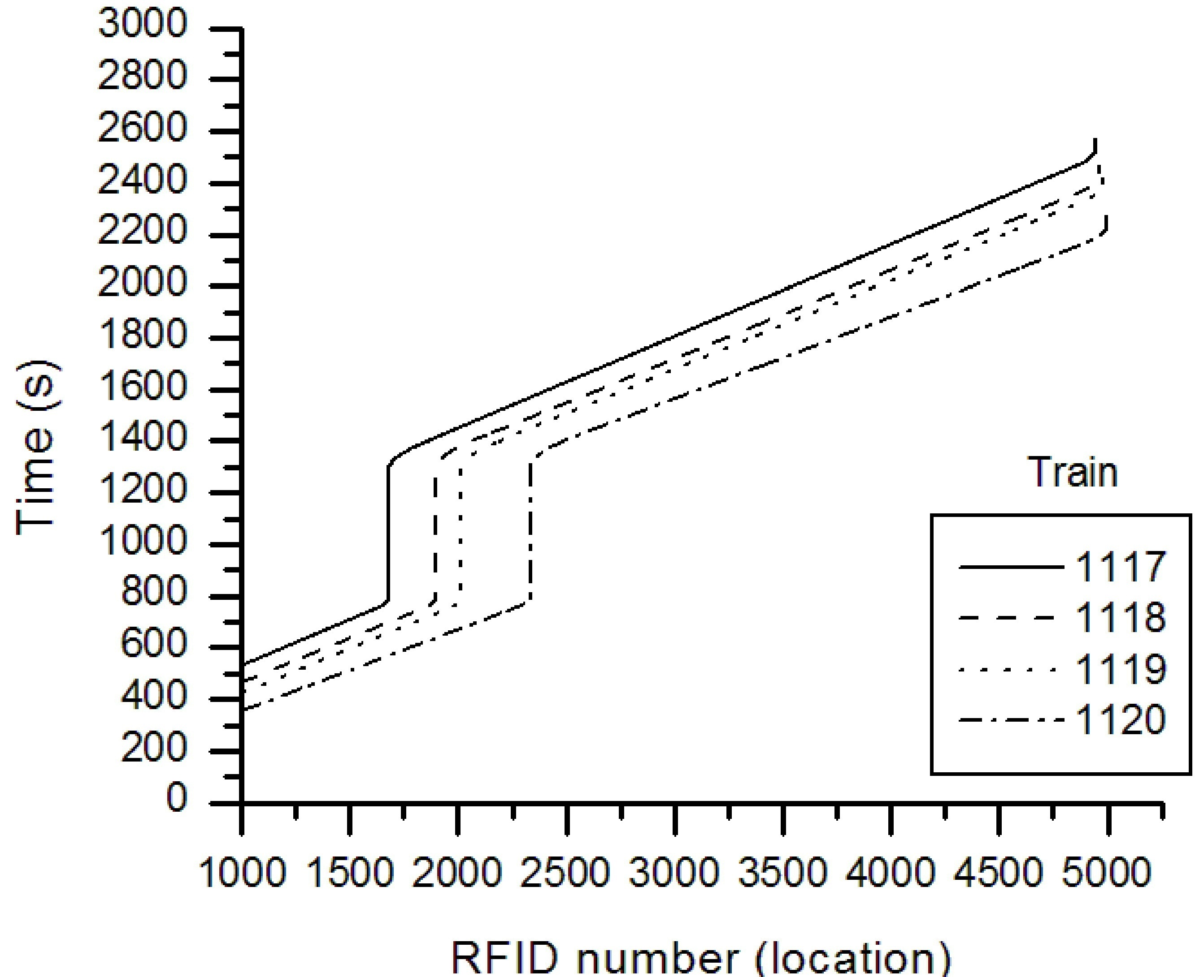
Fig. 1. Time versus location (communication fault)
Be sure that the symbols in your equation have been defined before the equation appears or immediately following. Symbols and variables should be written inside text using Equation tool of MS Word (Insert >> Equation >> Insert New Equation), for example $T$ might refer to temperature. Refer to “Eq. (1)” wherever you are citing equation 1 in the text.

Units
Use either SI (MKS) or CGS as primary units (SI units are strongly encouraged). English units may be used as secondary units (in parentheses). Avoid combining SI and CGS units.

Guidelines for Graphics Preparation

Types of Graphics
The following list outlines the different types of graphics published in JSR. They are categorized based on their construction, and use of color/shades of gray.

Color/Grayscale figures

Figures that are meant to appear in color, or shades of black/gray. Such figures may include photographs,
illustrations, multicolor graphs, and flowcharts.

Line Art figures

Figures that are composed of only black lines and shapes. These figures should have no shades or half-tones of gray, only black and white.

Tables

Grid like structures made of rows and columns, and contain text. They are composed of only black lines and text. Table should not be inserted in the form of image (Table should be created on MS Word using Table toolbar).

Multipart Figures
Figures compiled of more than one sub-figure presented side-by-side, or stacked. If a multipart figure is made up of multiple figure types (one part is lineart, and another is grayscale or color) the figure should meet the stricter guidelines.

File Formats for Graphics
Format and save your graphics using a suitable graphics processing program that will allow you to create the images as PostScript (PS), Encapsulated PostScript (.EPS), Tagged Image File Format (.TIFF), Portable Document Format (.PDF), Portable Network Graphics (.PNG) or JPEG, sizes them and adjusts the resolution settings. When submitting your final paper, your graphics should be inserted at the desired location in the manuscript as well as you can also submit the graphics individually in one of these formats along with the manuscript. You can also insert images inside a text box with no border, Square layout, Center horizontal alignment and Allow overlap unchecked.

Sizing of Graphics
Most charts, graphs, and tables are one column wide (3.5 inches / 88 millimeters / 21 picas) or page wide (7.16 inches / 181 millimeters / 43 picas). The maximum depth a graphic can be is 8.5 inches (216 millimeters / 54 picas). When choosing the depth of a graphic, please allow space for a caption. Figures can be sized between column and page widths if the author chooses, however it is recommended that figures are not sized less than column width unless when necessary.

Resolution
The proper resolution of your figures will depend on the type of figure it is as defined in the “Types of Figures” section. Color and grayscale figures should be at least 300dpi. Lineart, including tables should be a minimum of 600dpi.

Vector Art
In order to preserve the figures’ integrity across multiple computer platforms, we accept files in the following formats: .EPS/.PDF/.PS. All fonts must be embedded or text converted to outlines in order to achieve the best-quality results.

Caption of Figures or Tables
Place figure captions below the figures; place table titles above the tables. Both are Times New Roman, font size 9, center aligned, and sentence case. Please do not include captions as part of the figures, or put them in “text boxes” linked to the figures. Also, do not place borders around the outside of your figures. Note that “Fig.” is abbreviated. There is a period after the figure number, followed by a space.

Using Labels within Figures

Figure Axis Labels

For figure axis labels use words rather than symbols. As an example, write the quantity “Magnetization,” or “Magnetization M,” not just “M”. Put units in parentheses. Figure labels should be legible, approximately 8 to 10 point and Times New Roman.

Subfigure Labels in Multipart Figures and Tables

Multipart figures should be combined and labeled before final submission. Labels should appear centered below each subfigure in 8 point Times New Roman font in the format of (a) (b) (c).

Referencing a Figure or Table within Your Paper
When referencing your figures within your paper, use the abbreviation “Fig. 1” even at the beginning of a sentence. Tables should be numbered with Roman Numerals. Use “Table I” for referring a table within text.

Color Processing / Printing in JSR
JSR allows an author to publish color figures in online version of the paper, and automatically convert them to grayscale for print versions. Therefore, it is requested from the authors, information should not be lost during conversion of color image to grayscale image.

Theorems and Proofs
Theorems and related structures, such as axioms corollaries, and lemmas, are formatted using a hanging indent paragraph. They begin with a title and are followed by the text, in italics.
Theorem 1. Theorems, corollaries, lemmas, and related structures follow this format. They do not need to be numbered, but are generally numbered sequentially.
Proofs are formatted using the same hanging indent format. However, they are not italicized.
Proof. The same format should be used for structures such as remarks, examples, and solutions.

Algorithms
Each algorithm should be numbered as “Algorithm 1” followed by its caption. Algorithm caption is Times New Roman, font size 9, and center aligned. Text inside an algorithm is formatted using the same formatting as caption. However, they are italicized. Be sure that the symbols and variables in your algorithm have been defined before the algorithm appears or immediately following. Symbols and variables should be written inside text and algorithm using Equation tool of MS Word (Insert >> Equation >> Insert New Equation), for example $T$ might refer to temperature. Refer to “Algorithm 1” wherever you are citing algorithm 1 in the text. Line numbering in the algorithm is optional. However, line numbering helps authors during explanation of the algorithm.

Conclusion

A conclusion may review the main points of the paper, do not replicate the abstract as the conclusion. A conclusion might elaborate on the importance of the work or suggest applications and extensions. Formatting of conclusion heading as well as all headings followed by conclusion are same as first level heading except that they are unnumbered.
Algorithm 1. Failure detector algorithm of Strong S class
Initialization
1. $HMT_{Root}=Root process address of HMT$
Task 1: Send message to children processes at every monitoring interval
2. $for ∀ P_{i}C_{j}, P_{i} do$
3. ${To}_{i}\left[P_{i}C_{j}\right]=Time\left(\right)+OutT+InT+α$
4. $send "\text{Are-you-alive?" } toP_{i}C_{j}$
5. $end$
Task 2: Received acknowledgement from child process
6. $when "\text{I-am-alive"}+FP_{i}C_{j} is received from P_{i}C_{j}, P_{i} do$
7. $if\left({To}_{i}\left[P_{i}C_{j}\right]≥Time\left(\right)\right)$
8. $if\left(P_{i}C_{j}∈F_{i}\right)$
9. $F_{i}=F_{i}∩P_{i}C_{j}$
10. $CTree=Search\left(P_{i}C_{j}, HMT_{Root},"correct"\right)$
11. $UpdateHMT\left(CTree, "correct"\right)$
12. $endif$
13. $F_{i}=F_{i}{∪FP}_{i}C_{j}$
14. ${To}_{i}\left[P_{i}C_{j}\right]=∞$
15. $for ∀f_{i}∈{FP}_{i}C_{j} do$
16. $FTree=Search\left(f_{i}, HMT_{Root},"fault"\right)$
17. $UpdateHMT\left(FTree, "fault"\right)$
18. $end$
19. $endif$
20. $end$

Appendix
Appendixes, if needed, appear before the Acknowledgment.

Acknowledgment
It is optional. Use the singular heading even if you have many acknowledgments. Sponsors and financial support acknowledgments can be described here.

Footnotes
Number footnotes separately in superscripts (Insert >> Footnote). Place the actual footnote at the bottom of the column in which it is cited; do not put footnotes in the reference list (endnotes). Use letters for table footnotes (see Table I).

Copyright Form
Authors must submit an electronic Copyright Form upon submitting their final manuscript files. You can download the Copyright Form from the Download section on JSR website. The submitting author is responsible for obtaining agreement of all coauthors and any consent required from employers or sponsors before submitting an article. You are responsible for obtaining any necessary approvals and/or security clearances.

References
Manuscripts should include a thorough literature review and adequate reference citations to support the arguments and methodology of the research study (manuscript should include more than 20 references to assert a high level of rigor). All material that is paraphrased or quoted from another source is substantiated with an in-text reference citation. Manuscripts and references must strictly follow APA (American Psychological Association) style (The manuscripts will be returned for revision to format the manuscript and references in APA style if formatting is not correctly applied). References should relate only to the material that is cited within the content of the manuscript and may not include any bibliographic references that do not associate directly with the content of the manuscript. References should be in alphabetical order and not numbered in the text or in the reference list. Please do not include any abbreviations.
Consulting the APA style manual (http://www.apastyle.org/pubmanual.html) or (https://www.mendeley.com/guides/apa-citation-guide) is highly recommended for compiling manuscript submissions. The APA style manual ‘frequently asked questions’ and ‘helpful tips’ may also be found at: www.apastyle.org/faqs.html and www.apastyle.org/previoustips.html.

References should appear as

Book with one author
Author, A. A. (2005). Title of work. Location/City, State: Publisher.

Book with two authors
Author, A. A., & Author, B. B. (2005). Title of work. Location/City, State: Publisher.

Book with more than two authors
Author, A. A., Author, B. B., & Author, C. C. (2005). Title of work. Location/City, State: Publisher.

Journal article
Sawyer, S., & Tapia, A. (2005). The sociotechnical nature of mobile computing work: Evidence from a study of policing in the United States. International Journal of Technology and Human Interaction, 1(3), 1-14.

A publication in press
Junho, S. (in press). Roadmap for e-commerce standardization in Korea. International Journal of IT Standards and Standardization Research.

Edited book
Zhao, F. (Ed.). (2006). Maximize business profits through e-partnerships. Hershey, PA: IRM Press.

Chapter in an edited book
Jaques, P. A., & Viccari, R. M. (2006). Considering students’ emotions in computermediated learning environments. In Z. Ma (Ed.), Web-based intelligent e-learning systems: Technologies and applications (pp. 122-138). Hershey, PA: Information Science Publishing.

Report from a university
Broadhurst, R. G., & Maller, R. A. (1991). Sex offending and recidivism (Tech. Rep. No. 3). Nedlands, Western Australia: University of Western Australia, Crime Research Centre.

Published proceedings
Deci, E. L., & Ryan, R. M. (1991). A motivational approach to self: Integration in personality. In R. Dienstbier (Ed.), Nebraska Symposium on Motivation: Vol. 38. Perspectives on motivation (pp. 237-288). Lincoln: University of Nebraska Press.

Unpublished doctoral dissertation or master’s thesis
Wilfley, D. (1989). Interpersonal analyses of bulimia: Normal-weight and obese. Unpublished doctoral dissertation, University of Missouri, Columbia.

A presented paper
Lanktree, C., & Briere, J. (1991, January). Early data on the Trauma Symptom Checklist for Children (TSC-C). Paper presented at the meeting of the American Professional Society on the Abuse of Children, San Diego, CA.

Web site
VandenBos, G., Knapp, S., & Doe, J. (2001). Role of reference elements in the selection of resources by psychology undergraduates. Journal of Bibliographic Research, 5, 117- 123. Retrieved October 13, 2001, from http://jbr.org/articles.html

In-Text Citations
In-text citations should appear with author surname followed by publication year in parentheses.
Example: (Brown, 2002)

Variations of In-text Citations
- Citing several references in-text:
In alphabetical order, each citation is separated by a semicolon and ampersand (&). The word, “and” should not be used to separate entries.
Example: In most organizations, data resources are considered to be a major resource (Brown, 2002; Krall & Johnson, 2005; Smith, 2001).
- Citing author within sentence if author’s name is mentioned directly within the manuscript text:
Example: Brown (2002) states that the value of data is recognized by most organizations.
- Direct quote in-text citations:
Example: “In most organizations, data resources are considered to be a major organization asset” (Smith, 2001, pp. 35-36) and must be carefully monitored by the senior management.
Example: Brown (2002) states that “the value of data is realized by most organizations” (p. 45).
- In-text citations should not appear numbered:
Incorrect: In most organizations, data resources are considered to be a major resource [15; 30; 84].
Correct: In most organizations, data resources are considered to be a major resource (Brown, 2002; Krall & Johnson, 2005; Smith, 2001).
- For quotes exceeding 40 words, quotes should be formatted as a block quote (a block quote uses no quotation marks, and its margins are indented from the left; a period is placed before the parenthetical in-text citation):
Example: As an ever-growing number of people around the world have gained access to e-mail and Internet facilities, it has become clear that the communicative environment provided by these tools can foster language learning. E-mail facilitates access to speakers of one's target language. (Vinagre & Lera, 2007, p. 35)

Sample References
Aguilera, M.K., Chen, W., & Toueg, S. (1997). Heartbeat: A timeout-free failure detector for quiescent reliable communication. Distributed Algorithms, Lecture Notes in Computer Science, 1320, 126-140.
Arevalo, S., Anta, A.F., Imbs, D., Jimenez, E., & Raynal, M. (2012). Failure detectors in homonymous distributed systems (with an application to consensus). In 32nd International Conference on Distributed Computing Systems (pp. 275-284), IEEE Computer Society, Washington, DC, USA.
Benenson, Z., Fort, M., Freiling, M.C., Kesdogan, D., & Penso, L.D. (2006). Trusted Pals: Secure multiparty computation implemented with smart cards. Lecture Notes in Computer Science, Springer, 4189, 34–48.
Chandra, T.D., & Toueg, S. (1996). Unreliable failure detectors for reliable distributed systems. Journal of the ACM, 43(2), 225-267.
Chandra, T.D., Hadzilacos, V., & Toueg, S. (1992). The weakest failure detector for solving consensus. In 11th Annual ACM Symposium on Principles of Distributed Computing (pp. 147-158), Vancouver, BC, Canada.
Chandra, T.D., Hadzilacos, V., & Toueg, S. (1996). The weakest failure detector for solving consensus. Journal of the ACM, 43(4), 685–722.
Cortinas, R. (2011). Failure detectors and communication efficiency in the crash and general omission failure models. Unpublished doctoral dissertation, University of the Basque country.
***

Corresponding Author
It is recommended that footnotes be avoided. Instead, try to integrate the footnote information into the text.

